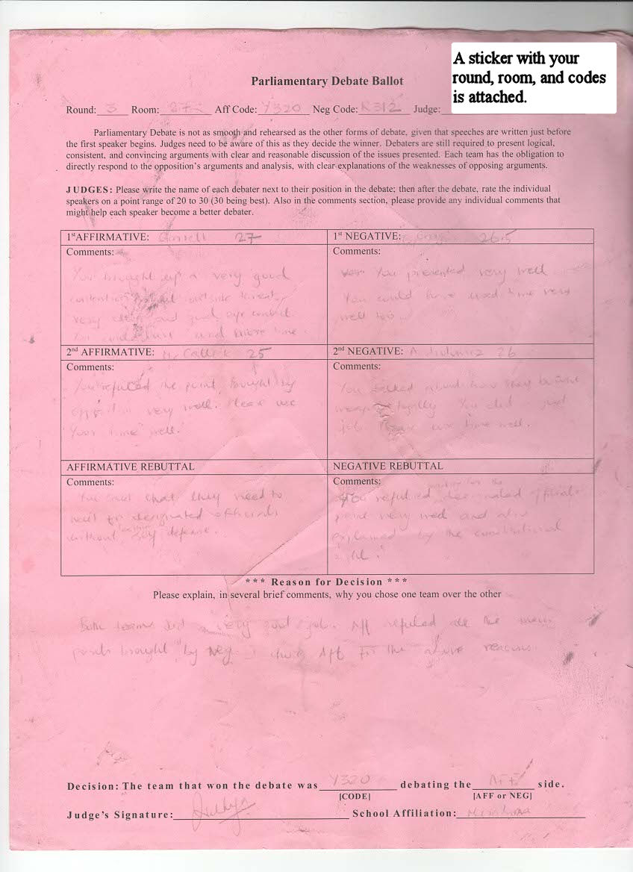
8. This section is often more important to competitors than individual assessments. They mostly want to know why they won or lost the debate.
6. Speaker points
(2.)
(1.)
4. Last name
9. Be specific, positive, and encouraging, but suggest ways to improve.
- (topic debated)
5. This is the most important section to fill out.
7. Fill out the info from the attached sticker.
Steps:
- When your name is called out, pick up the ballot from the organizer. On the ballot will be the type of debate, your room, and the round number. Grab a time sheet and a map from the front desk (if you haven’t already) and get to your room as quickly as possible.
- The Aff is always on the left side of your ballot, and the Neg is always on the right. Make it easy for yourself! Ask the competitors to sit in the order that is on your ballot so you are less likely to write in the wrong section.
- Students are not allowed in the room without you, but sometimes they are not outside the door when you arrive. If you have time now, fill out the info from the attached sticker at the top. Otherwise, start the round as soon as everyone is ready. While not important, I like to put the topic of the debate on the ballot.
- As each speaker speaks, put their last name in the box. Take separate notes on the debate.
- At the end of the debate, make your decision promptly, and return to the judges room. If you need more time, show the front desk your decision and then finish filling out the ballot.
- Speaker points are arbitrary, but they do rank the students for certain awards. Put a number for each individual.
- If you haven’t had a chance, fill out the info at the top from the sticker. It seems redundant, but you are making several copies of the ballot, and the info is not on all of them.
- What swayed you one way over the other?
- Constructive comments are appreciated. Why did/didn’t they get 30 speaker points this debate?

Quick Ref:
- Pick up ballot and go to room.
- Ask competitors to sit according to your ballot layout.
- Fill out top if you have time, otherwise put in debate topic and begin.
- Write last name of each speaker as they speak. Take separate notes on the debate
- Make your decision promptly and return to judges room. Show your decision to the front desk, then finish filling out the ballot.
- Give speaker points to each individual
- Fill in the top info
- What swayed you one way over the other?
- Why did/didn’t they get 30 speaker points this debate?
- Turn in ballot

